Concepts first, jargon second improves student articulation of understanding
Lisa McDonnell, Megan Barker, and Carl Wieman

Supplemental Material

Figure S1. Clicker question asked in class to identify students who had completed the pre-reading quiz. Only those who chose option A were included in our analysis. Those that chose option E were analyzed as a control for the effects of completing the pre-class reading.

Table S1: Sample of pre-class reading given to the treatment (concepts-first) and control (jargon + concepts) groups. Text in pre-reading figures were similarly modified as appropriate for concepts-first group.
Passage from Control Group (jargon + concepts) | Passage from Treatment Group (concepts-first, jargon removed)
Cells today have four different ribonucleotides, each of which contains a different nitrogenous base. These bases, diagrammed in Figure 1C, belong to structural groups called purines and pyrimidines. Ribonucleotides include the purines adenine (A) and guanine (G), and the pyrimidines cytosine (C) and uracil (U). | Cells today have four different RNA monomers, each of which contains a different base. These bases, diagrammed in Figure 1C, are either large (two rings) or small (one ring). RNA monomers include the large bases A and G, and the small bases C and U.
A genome is an organism’s complete set of hereditary DNA molecules. In humans, a copy of the entire genome—more than 3 billion DNA base pairs—is contained in all cells that have a nucleus (actually most of our cells are diploid, meaning we have two copies of the genome). There can be as few as 1 to more than 100 chromosomes in a eukaryotic genome. | All of the DNA sequence that is passed on from one generation to the next is considered the total hereditary genetic material of a haploid cell. This hereditary DNA material consists of all DNA sequences. In humans, the total hereditary genetic material —DNA sequences that total more than 3 billion DNA base pairs—is contained in all cells that have a nucleus (actually most of our cells are diploid, meaning we have two sets of hereditary genetic material). Eukaryotic hereditary genetic material can be as few as 1 to more than 100 chromosomes.

Table S2: Post-test questions
Question description | Question text  (* correct answers for multiple choice questions; Rubrics for free-response questions in Table S2)
DNA structure topic; multiple choice with jargon | 1. In normal double-stranded DNA, why are purines base-paired with pyrimidines?  - Because a purine-purine pair would be too small, and a pyrimidine-pyrimidine pair would be too large  - Because the number of A must equal the number of T and the number of G must equal the number of C  - Because the strongest stacking interactions are found between purines and pyrimidines, making the DNA more stable  - Because purine-pyrimidine pairs maximize the number of hydrogen bonds, making the DNA more stable.  - (*) Because complementary purine-pyrimidine base pairs have the same geometries
DNA structure topic; multiple choice without jargon | 2. Why does double-stranded DNA have a regular, uniform structure?  - Because a regular structure allows the bases to pack on top of each other  - Because the bases can make non-covalent interactions both between strands, and within the same strand  - (*) Because complementary base pairs always cause the same distance between DNA backbones  - Because the number of A must equal the number of T & the number of G must equal the number of C  - Because the hydrogen-bonding is the same in all base pairs containing one large base with one small base
Genome topic; multiple choice with jargon | 3. You are comparing the genetic material of two species. Species A has 100 million base pairs in one of its haploid cells. Species B has 96 million base pairs in one of its haploid cells. From this data, you can conclude that:  - (*) The genome of species A is larger than the genome of species B.  - Species A has more genes than species B.  - The genome of species B is larger than the genome of species A.  - Species B has more genes than species A.  - None of the above can be concluded based on this data.
Genome topic; multiple choice without jargon | 4. Examine the data in the table below:  Species Amount of DNA in a haploid cell (base pairs) Number of base-pairs that code for proteins  A 8,000,000 8,000  B 200,000,000 19,000  C 19,000,000 500,000  Based on this information, which statement is true? The hereditary genetic material:  - of species A is the largest.  - (*) of species B is the largest.  - of species C is the largest.  - of species B contains the most genes.  - None of the above can be concluded based on this information.
DNA structure topic – free response | 5. A double-stranded DNA molecule is shown below, with a portion of its sequence written out. There are several non-complementary base pairs, highlighted.  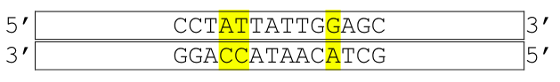  The overall stability of this DNA molecule is less than a normal double-stranded DNA molecule. Explain why in 1-2 brief sentences.
Genome topic – free response | 6. You are researching a newly-discovered plant, and you want to determine all of the DNA sequences (genes and the non-coding sequences in-between genes) in this plant.  What genetic material should you determine the sequence of? Explain why, in 1-2 short sentences.
Table S3: Free-response questions scoring rubrics
Question 5 | Rubric | Concept 1 (Inter-strand size/distance altered) |  |  | Concept 2 (Interactions affected) | Jargon: “Stacking interactions”  Score 1 or 0 | Jargon: “Hydrogen bonds”  Score 1 or 0 | Jargon: “Purine/Pyrimidine”  Score 1 or 0
 |  | Argument 1: Size of bases and/or base-pairs.  Score 1 or 0 | Argument 2: Changes fit/distance between strands.  Score 1 or 0 |  | Argument 3: Interactions are affected (described effects to hydrogen bonds or hydrophobic interactions)  Score 1 or 0
Question 6 | Rubric | Concept 1(Genome is all of the genetic material in a cell, including coding and non-coding sequences) |  |  |  | Concept 2 (heritability of the genome) |  | Jargon: Genome Score 1 or 0
 |  | Argument 1: The genome is all the genetic material/DNA sequences in a cell |  | Argument 2: Genome includes all coding and non-coding sequences |  | Argument 3: Genome is inherited/hereditary  Score 1 or 0

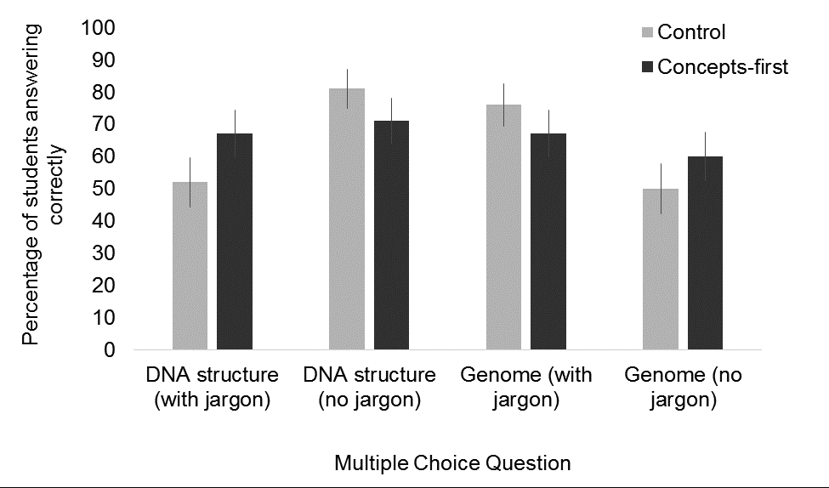Figure S2. Multiple Choice Scores. Multiple choice questions within each topic are isomorphic (containing or not containing jargon). No significant differences were observed between groups on the same question (Chi squared test, all p>0.06). Error bars are standard error of the mean for binomial data.

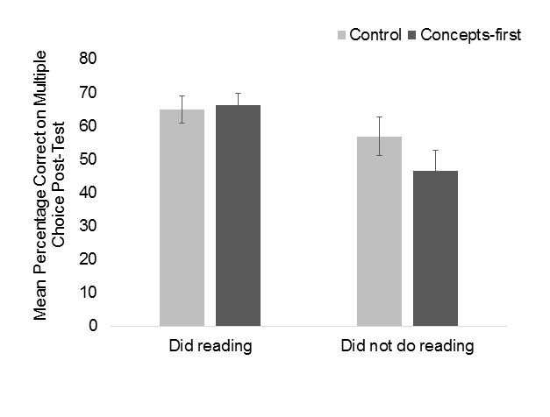
Figure S3. Student scores on multiple-choice questions of post-test. Comparing students who did the pre-reading and students who did not complete the pre-class reading. Students who did not complete the pre-reading performed significantly worse on the multiple-choice post-test items (t-test, p<0.001). Error bars are standard error.

Table S3: Number of arguments given in post-test free response questions. Comparing arguments between students who did the pre-reading and student who did not complete the pre-class reading. The number of student responses that included 0, 1, 2, or 3 correct arguments on the free response post-test items.
 | DNA structure |  |  |  | Genomes
Number of correct arguments | Did not do reading |  | Did reading |  | Did not do reading |  | Did reading
 | Control | Concepts-first | Control | Concepts-  first | Control | Concepts-first | Control | Concepts-  first
0 | 8 | 7 | 26 | 18 | 20 | 15 | 31 | 22
1 | 10 | 13 | 8 | 15 | 2 | 7 | 9 | 9
2 | 3 | 2 | 6 | 4 | 0 | 0 | 2 | 10
3 | 1 | 0 | 2 | 5 | 0 | 0 | 0 | 1

Table S4: Statistical comparison of the number of arguments given in free-response questions. These values were calculated from the counts in Table S3 using a Chi squared test. For students who did not complete the reading there was no difference between the control and treatment group. Students who did not complete the pre-reading had significantly fewer arguments than those that did complete the pre-reading. These three comparisons combined indicate that 1) the reading has an impact on learning, and 2) the inclusion of jargon in the reading has an impact on learning.
Comparison | Chi-squared p-value, within this topic
 | DNA structure | Genomes
Did not do reading control vs.  Did reading control | < 0.0001 | < 0.005
Did not do reading concepts first vs. Did reading concepts-first | < 0.005 | < 0.005
Did reading control vs.  Did reading concepts-first | < 0.005 | < 0.0005

